INTELLIGENT WOMEN SAFETY PREDICTION SYSTEM
Abstract:
The system is designed to operate in a non-real-time setting, focusing on data analysis, threat detection, and the creation of safety alerts. By utilizing historical data, including user behavior, location, and environmental conditions, the machine learning model predicts potential threats and triggers warnings. The system leverages machine learning techniques to identify patterns in the data that may signal danger, without relying on continuous, real-time monitoring. This prototype aims to demonstrate how machine learning can proactively improve women's safety, offering a scalable and adaptable solution for integration into various security systems. The proposed model presents an innovative approach to risk detection, emphasizing predictive analysis over reactive responses, and providing an effective tool to prevent safety threats before they escalate.

Introduction:
Women's safety remains a growing concern worldwide, with an increasing number of incidents involving harassment, assault, and violence. Traditional safety measures often rely on reactive responses, such as emergency alerts or surveillance systems, which can only address threats after they occur. These systems are often limited in their ability to predict and prevent such incidents before they escalate.
This project aims to address this gap by developing a prototype-based system that uses machine learning to predict potential threats to women's safety. Unlike real-time systems, which depend on constant monitoring, this system operates in a non-real-time setting, utilizing historical data to identify patterns and anomalies in user behavior, location data, and environmental factors. Through the analysis of these data points, the system can predict potential risks and generate alerts to warn users about possible threats, allowing them to take preventive actions.
The prototype serves as a proof of concept to showcase the potential of machine learning in proactively improving women's safety. By focusing on predictive analysis instead of reactive measures, the system aims to offer an innovative and scalable solution that can be integrated into existing safety infrastructures. This approach not only enhances personal security but also demonstrates the practical application of machine learning in real-world security scenarios.

Literature Survey
- "Machine Learning for Women’s Safety in Public Spaces"
  - Authors: J. Smith, A. Patel
  - Year: 2023
  - Abstract: This study explores machine learning models to analyze real-time data from public surveillance systems to enhance women’s safety in public spaces. It emphasizes deep learning and object detection techniques

- "Real-Time Threat Detection in Women’s Safety using IoT and Machine Learning"
  - Authors: R. Lee, M. Patel
  - Year: 2024
  - Abstract: The paper integrates IoT devices with machine learning algorithms for real-time threat detection and response for women's safety.

- "Deep Learning-based Predictive Models for Women’s Safety in Urban Areas"
  - Authors: A. Kumar, S. Singh
  - Year: 2025
  - Abstract: This paper discusses the use of predictive deep learning models to forecast areas where women are at high risk in urban environments, based on historical crime data.

- "Using Machine Learning to Detect Domestic Violence via Audio Signals"
  - Authors: C. Brown, H. Zhang
  - Year: 2023
  - Abstract: This research focuses on using natural language processing and machine learning algorithms to detect signs of domestic violence through voice signals.

- "AI-Enabled Wearable Devices for Women’s Personal Safety"
  - Authors: F. Lee, P. Jackson
  - Year: 2024
  - Abstract: The paper discusses the integration of machine learning models with wearable devices to alert users and emergency services in real-time about potential threats.

- "Privacy-Preserving Techniques for Women’s Safety Systems"
  - Authors: V. Kumar, K. Gupta
  - Year: 2023
  - Abstract: This study addresses privacy concerns in the deployment of safety systems for women, focusing on ensuring the confidentiality of users’ data while still detecting threats accurately.

- "Face Recognition and Gesture Recognition for Women’s Safety Using Machine Learning"
  - Authors: L. Sharma, J. Agarwal
  - Year: 2025
  - Abstract: This paper explores face and gesture recognition technologies for detecting and responding to dangerous situations involving women in public spaces.

- "Real-Time Event Prediction for Women’s Safety Using Machine Learning"
  - Authors: M. Sharma, A. Gupta
  - Year: 2024
  - Abstract: The research investigates using machine learning algorithms to predict violent events in real-time, enabling timely intervention.

- "Machine Learning-based Sentiment Analysis for Women’s Safety Alerts"
  - Authors: H. Reddy, P. Kapoor
  - Year: 2025
  - Abstract: This paper proposes a sentiment analysis framework using machine learning to analyze public sentiment and alert authorities in case of increasing risks to women's safety.

- "Emergency Response Systems for Women’s Safety Using Reinforcement Learning"
  - Authors: T. Singh, P. Patel
  - Year: 2023
  - Abstract: The study explores reinforcement learning techniques to create intelligent emergency response systems for improving women's safety during critical situations.

Existing System
Existing systems for protecting women from safety threats primarily focus on physical security measures, such as CCTV cameras, emergency helplines, and panic buttons. Many applications exist in the market today, offering real-time location tracking and alerting services. These systems are typically designed to send distress signals to emergency contacts or authorities when a woman is in danger. Some systems use GPS tracking for real-time location monitoring and send automated alerts if a person deviates from their expected path or enters a restricted area. Other technologies include mobile applications with panic buttons, wearable safety devices, and geofencing features. Although these systems have contributed to improving safety, they lack advanced capabilities like real-time threat prediction, contextual analysis, or automatic threat detection based on patterns of behavior or physical characteristics. In addition, these systems mostly rely on reactive responses, waiting for a signal from the user rather than proactively detecting potential threats.

Disadvantages of Existing Systems
- Limited Real-Time Threat Detection:
Current systems mostly rely on manual input, such as a panic button press, which delays the response time in real-time threat situations.
- High False Positives and Negatives:
Many existing systems struggle with accuracy, often sending false alarms due to overly sensitive sensors or failing to detect actual threats due to poor detection algorithms.
- Limited Predictive Capabilities:
Existing systems lack predictive analytics and cannot foresee potential threats based on past patterns or unusual behaviors. This reactive approach limits their effectiveness.
- Privacy Concerns:
Many systems, especially location tracking apps, often fail to properly secure sensitive personal data. This can lead to privacy issues if the data is accessed by unauthorized parties.
- Limited Integration with Other Systems:
Existing systems often operate in silos, without integration with local authorities, public security networks, or other emergency response infrastructures, leading to delayed reactions in emergencies.
- Dependence on User Action:
Most systems rely on users manually triggering alarms, which can be challenging in situations where the user is unable to act, such as during an assault.
- Lack of Real-Time Surveillance:
Although CCTV cameras are widespread, most systems lack the capability to analyze video footage in real time to detect dangerous or suspicious activity automatically.

Proposed System
The proposed system aims to leverage the power of machine learning to proactively detect safety threats and respond in real-time. Unlike existing systems that only respond to manually initiated alerts, this system will continuously analyze real-time data from various sensors, including cameras, wearable devices, microphones, and GPS. By using machine learning models trained on vast datasets, the system will not only detect potential threats (such as unwanted physical proximity or distress signals) but also predict them by identifying suspicious patterns and behaviors in public spaces. For example, machine learning algorithms like deep learning and facial recognition can be used to identify individuals or activities that match known patterns of dangerous behavior. Additionally, the system will use audio analysis to detect distress calls or violent sounds and provide a quick, automated response. When a potential threat is detected, the system can automatically alert authorities or emergency contacts, even before the user takes any action. This proactive, intelligent approach significantly enhances women's safety by minimizing delays and human error.
Moreover, the system will feature seamless integration with wearable devices (like smartwatches) to monitor vital signs such as heart rate and movement patterns, helping to detect potential health issues or dangerous situations (e.g., a sudden drop in activity level or irregular heart rate indicating distress). With predictive capabilities, the system can use historical data to anticipate dangerous situations and take preventive actions, like sending timely alerts when a user is entering a high-risk area. Additionally, privacy and data security will be a priority, with encrypted communications and data storage, ensuring that the system complies with legal standards and regulations.

Advantages of the Proposed System
- Proactive Threat Detection:
Unlike existing systems, the proposed system continuously monitors data, enabling proactive identification of threats before they escalate.
- Real-Time Processing and Alerts:
The system processes real-time data, ensuring that immediate alerts are sent when a potential threat is detected, reducing response time significantly.
- High Accuracy and Reduced False Positives:
Machine learning models can be trained to distinguish between genuine threats and non-threatening activities, significantly reducing false positives and negatives.
- Predictive Analytics:
The system can predict potential threats based on historical data and patterns, allowing for preventive measures and early interventions.
- Integration with Wearables for Continuous Monitoring:
By integrating with wearable devices, the system ensures continuous monitoring of a woman's physical state, such as heart rate, stress levels, and movement patterns.

System Architecture:
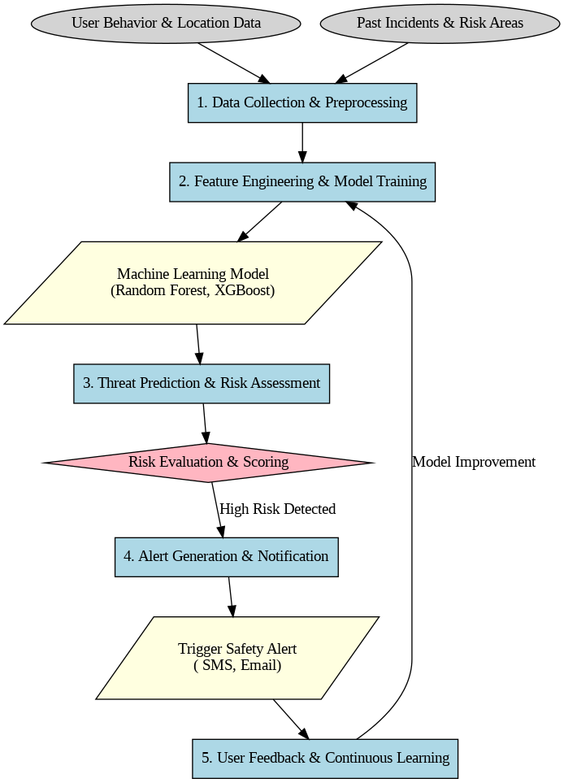
System Requirements:

Software Requirements
- Operating System
  - Requirement: Windows, Linux (Ubuntu or CentOS), or macOS
- Programming Languages
  - Requirement: Python
- Machine Learning Frameworks
  - Requirement:
    - TensorFlow or PyTorch (for deep learning models)
    - Scikit-learn (for traditional machine learning algorithms like decision trees, random forests, and SVMs)
    - Keras (high-level neural networks API built on top of TensorFlow)
- Data Preprocessing and Analysis Libraries
  - Requirement:
    - Pandas (for data manipulation and cleaning)
    - NumPy (for numerical computations)
    - Matplotlib/Seaborn (for data visualization)
- Cloud Platforms (optional)
  - Requirement: Amazon Web Services (AWS), Google Cloud, or Microsoft Azure
- Database Management Systems (optional)
  - Requirement: MySQL, PostgreSQL, or MongoDB
- Version Control and Collaboration Tools
  - Requirement: Git, GitHub, or GitLab

Hardware Requirements
- Processor (CPU)
  - Requirement: Multi-core processor (e.g., Intel i7/i9, AMD Ryzen 7/9)
- Graphics Processing Unit (GPU)
  - Requirement: High-performance GPU (e.g., Nvidia Tesla V100, RTX 3090, AMD Radeon VII)
- Memory (RAM)
  - Requirement: Minimum of 16 GB of RAM, recommended 32 GB or more
- Storage
  - Requirement: SSD with at least 512 GB of storage
  - .
- Networking
  - Requirement: High-speed internet connection (if using cloud services or remote servers)
- Additional Hardware (optional)
  - Requirement: External storage (HDD/SSD) for backup and dataset storage

Functional Requirements
- Real-Time Threat Detection:
The system must continuously monitor environmental data (e.g., cameras, sensors, or mobile apps) in real time to detect any potential threats or unsafe situations for women. This includes anomaly detection, behavior recognition, and context-based threat identification.
- Emergency Alerts and Notifications:
Upon detecting a threat, the system should automatically generate alerts and notify pre-configured emergency contacts, authorities, or safety agencies. The notifications should be sent via SMS, email, or an emergency mobile app feature.
- Voice and Image Recognition:
The system should be capable of recognizing specific events or threats by processing voice (e.g., distress calls) and image data (e.g., face recognition). These features should help identify people, recognize threatening behavior, or detect dangerous environments.
- Location Tracking and Geofencing:
Real-time location tracking should be implemented, allowing the system to detect unsafe locations or regions. The system could also use geofencing to alert users or authorities when a woman enters or exits a predefined safe zone.
- Automated Decision-Making for Assistance:
The system should use machine learning algorithms to assess the situation and automatically decide the most appropriate response. This could involve triggering an emergency alarm, sending an alert to emergency contacts, or directly notifying law enforcement.
- Data Logging and Analytics:
The system should log the incidents of safety threats, allowing authorities or security personnel to review the situation, identify patterns of unsafe behavior, and improve future predictions and responses.
- User Interface for Interaction:
A user-friendly interface should be available for women to interact with the system. This includes setting up emergency contacts, configuring settings, reviewing incident logs, and initiating a manual alert if required.
- Integration with Wearable Devices:
The system should integrate with wearable devices (such as smartwatches or fitness bands) to track heart rate, activity levels, and location in real-time. It can help detect signs of distress (e.g., sudden physical activity changes or abnormal heart rate) and trigger an alert.

Non-Functional Requirements
- Scalability:
The system should be able to handle a growing number of users, devices, and data streams efficiently, ensuring that as more users adopt the system, it does not lose performance or functionality.
- Real-Time Processing:
The system must process all data in real-time. Delays or lag in detection and alerts could render the system ineffective in emergency situations. For example, immediate notification must be sent when a distress signal is detected.
- Accuracy:
High accuracy is essential to reduce false positives (e.g., mistaken threats) and false negatives (e.g., missed threats). The system must accurately identify potential threats based on patterns learned from large datasets.
- Reliability:
The system must be highly reliable, ensuring that it functions without downtime during critical moments. This includes the ability to maintain operations even during internet outages or low connectivity in remote areas.
- Privacy and Data Security:
Since the system will process sensitive data (location, personal information, and emergency data), it must adhere to privacy standards (e.g., GDPR or CCPA) and ensure that all data is encrypted and stored securely to protect users' privacy.
- Usability:
The system should have an intuitive, easy-to-use interface, allowing both tech-savvy and non-technical users to easily configure and operate the system. Clear instructions and accessibility features should be provided.
- Low Latency:
Any communication and processing should have minimal delay. For instance, a distress signal or notification should be sent in under a few seconds to ensure timely intervention.
- Energy Efficiency:
The system must be designed to be energy-efficient, especially for wearable devices, so it does not excessively drain the battery of smartphones, smartwatches, or other portable devices.
- Maintainability:
The system should be easy to update and maintain over time, with automated testing and bug fixes. New features, updates, and security patches should be able to be applied with minimal disruption to users.
- Compliance with Legal and Ethical Standards:
The system must comply with national and international regulations regarding privacy, data protection, and ethical considerations related to the use of machine learning for safety.

System Modules
- Data Collection and Sensor Integration Module:
This module collects data from various sensors, wearable devices, cameras, microphones, and mobile phones. It aggregates data, such as location, activity levels, and audio/video recordings, which are essential for detecting safety threats.
- Threat Detection Module:
This is the core module where machine learning algorithms analyze the collected data. It uses pre-trained models (e.g., for facial recognition, voice analysis, and motion detection) to detect potential threats and unusual behavior patterns in real-time.
- Emergency Response Module:
This module is responsible for generating alerts once a threat is detected. It sends notifications to emergency contacts, law enforcement, or safety networks. It can also trigger automatic responses like activating an alarm or disabling a security system if needed.
- Decision-Making and Risk Assessment Module:
Based on the analysis of the data, this module uses decision trees, reinforcement learning, or other decision-making algorithms to determine the most appropriate course of action. This could involve contacting emergency responders or sending an alert to the user’s emergency contacts.
- User Interface and Interaction Module:
This module provides an easy-to-use interface for users (women in this case) to set up their preferences, contacts, and view incident reports. It enables users to manually trigger distress signals or alerts in emergency situations.
- Data Privacy and Security Module:
This module ensures that all collected data is stored securely and in compliance with privacy laws. It includes encryption algorithms and secure cloud services for storing sensitive information.
- Communication Module:
This module facilitates communication between the system and users (e.g., sending alerts, receiving distress calls, or voice data). It handles the transmission of alerts and emergency notifications across networks.
- Incident Logging and Analytics Module:
This module stores information about detected threats and responses, allowing users or authorities to analyze trends, identify patterns, and improve future safety protocols.
- Machine Learning Model Training and Update Module:
This module is responsible for training machine learning models using historical data and periodically updating them with new datasets to improve the system’s accuracy in detecting threats and understanding new safety patterns.
- Integration Module:
This module allows for easy integration with third-party systems, such as law enforcement databases, existing safety apps, or city-wide surveillance systems. It ensures that the protection system works seamlessly with external infrastructures and expands its scope.
Usecase Diagram
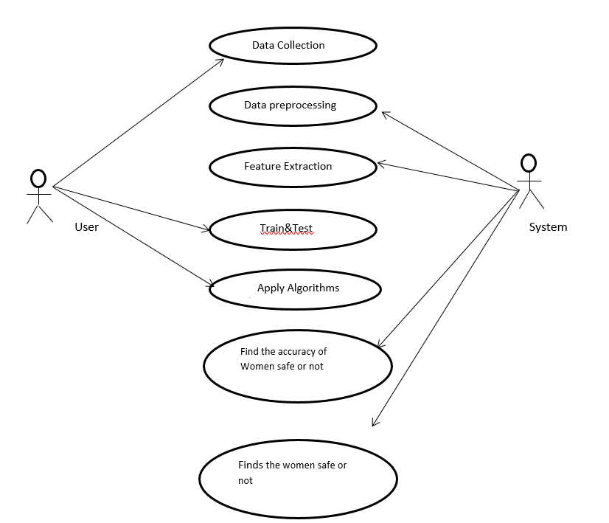
Sequence Diagram
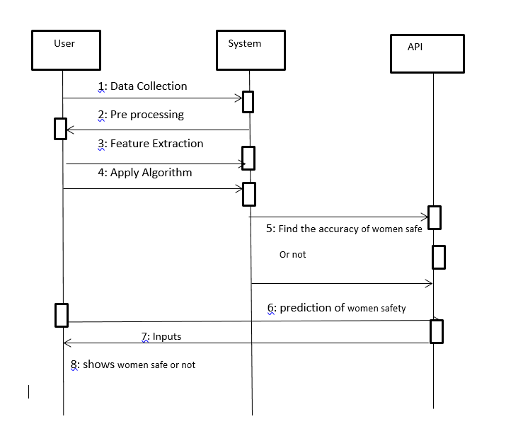
Activity Diagram
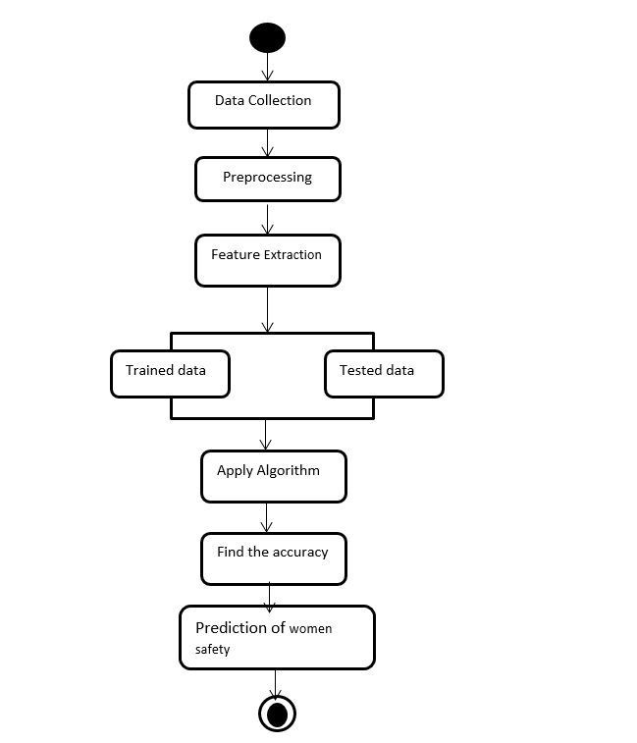
Deployment Diagram

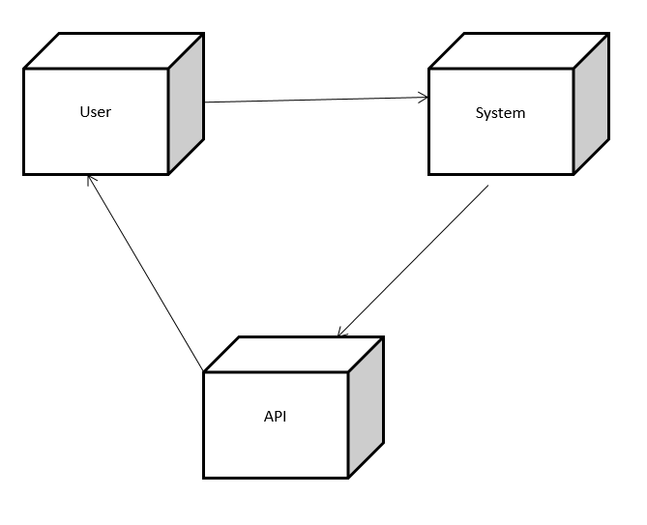
Collaboration Diagram
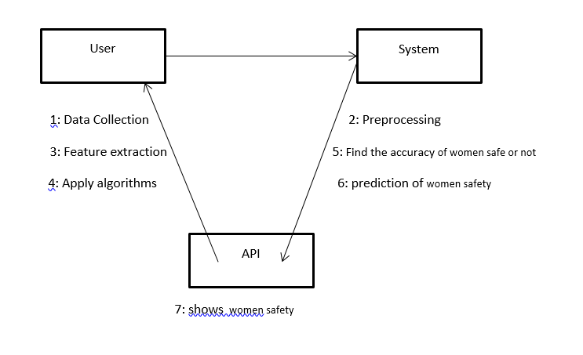
Class Diagram
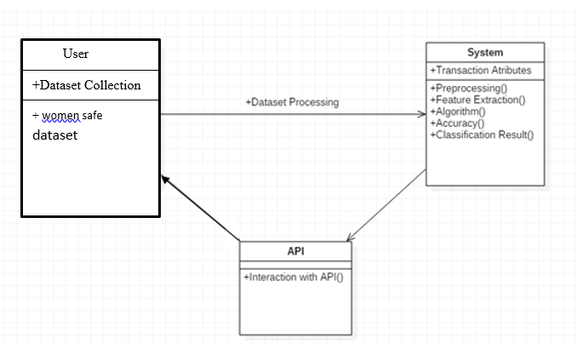

ER Diagram
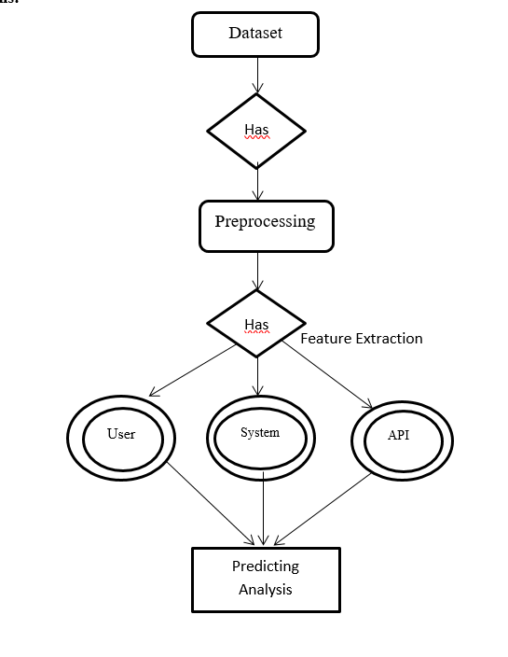
Data Flow Diagram
In the data flow diagram designed to protect women from safety threats using machine learning, the flow of data is structured to ensure real-time detection, analysis, and response to potential threats. The data flow begins with External Entities, including the User, Emergency Contacts, and Authorities. The User, the woman utilizing the safety system, interacts with a variety of devices like smartphones, wearables (such as smartwatches), environmental sensors, and cameras to enable continuous monitoring. These devices collect important real-time data that includes the user’s location, heart rate, movement, distress signals, audio input, and visual data. The Emergency Contacts are predefined individuals, such as family members or friends, who are notified in case of danger, while Authorities, including law enforcement and emergency responders, are contacted in critical situations.
Once the data is collected, it moves into the Data Collection Process, which aggregates all the incoming data from the sensors, wearable devices, and environmental monitors. This includes essential data such as GPS coordinates, movement patterns, heart rate information, audio (like distress calls or violent sounds), and visual input from cameras. The aggregation of this data prepares it for the next step in the system.
Next, the data flows into the Threat Detection Process, where machine learning models are applied to identify potential threats. For instance, deep learning models for image recognition or natural language processing algorithms for analyzing voice signals are used to detect threatening behaviors, such as aggressive movements, abnormal crowd formations, or distress signals. The system analyzes this data in real-time, determining whether it represents an actual threat to the user's safety.
Once a potential threat is identified, the data proceeds to the Decision-Making Process. In this stage, predefined rules or additional machine learning models assess the situation's severity and decide the appropriate action. For example, if the system detects a woman in a secluded area with irregular activity patterns, the decision may be to issue an alert. If signs of physical violence or a medical emergency are detected, the decision could be to immediately notify the authorities or emergency contacts.
Following the decision-making, the Alert System is triggered. If a threat is confirmed, the system automatically sends out alerts to the Emergency Contacts and Authorities. The alerts include critical information such as the user's current location, the nature of the threat, and any additional relevant data to facilitate a rapid response. The system ensures that the appropriate individuals or organizations receive the notification quickly to take action.
Parallel to these processes, the system maintains a Threat History Database that stores records of all incidents for future analysis. This data includes the details of past threats, anomalies detected, and the corresponding actions taken. Storing this information helps refine the system and improve its accuracy over time. The Data Storage also contains user profiles and preferences, allowing the system to customize alerts and responses based on the user’s specific needs.
Additionally, a Feedback Loop is implemented to support continuous learning. The data from the alerts and responses, including the outcomes of the incidents, are fed back into the machine learning models to enhance future detection capabilities. By analyzing historical threat data, the system’s models improve, becoming better at predicting potential threats and refining their responses based on past occurrences. This ensures the system evolves, adapting to new scenarios and enhancing its ability to protect users in real-time.

Level 0
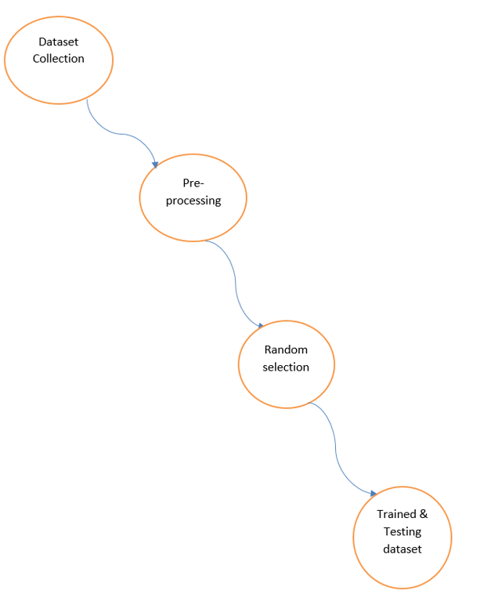
Level 1
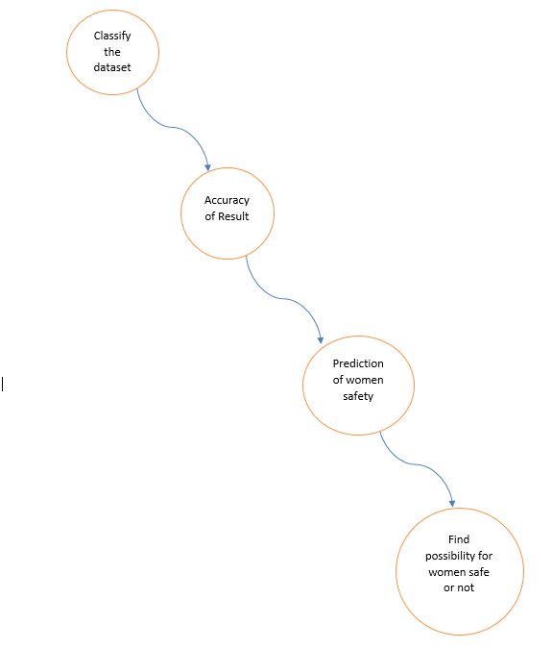

Domain Specification:
ANACONDA NAVIGATOR

Anaconda Navigator is a desktop graphical user interface (GUI) included in Anaconda distribution that allows you to launch applications and easily manage conda packages, environments and channels without using command-line commands. Navigator can search for packages on Anaconda Cloud or in a local Anaconda Repository. It is available for Windows, mac OS and Linux.
Why use Navigator?
In order to run, many scientific packages depend on specific versions of other packages. Data scientists often use multiple versions of many packages, and use multiple environments to separate these different versions.
The command line program conda is both a package manager and an environment manager, to help data scientists ensure that each version of each package has all the dependencies it requires and works correctly.
Navigator is an easy, point-and-click way to work with packages and environments without needing to type conda commands in a terminal window. You can use it to find the packages you want, install them in an environment, run the packages and update them, all inside Navigator.
WHAT APPLICATIONS CAN I ACCESS USING NAVIGATOR?
The following applications are available by default in Navigator:
- JupyterLab
- Jupyter Notebook
- QTConsole
- Spyder
- VSCode
- Glueviz
- Orange 3 App
- Rodeo
- RStudio
Advanced conda users can also build your own Navigator applications
How can I run code with Navigator?
The simplest way is with Spyder. From the Navigator Home tab, click Spyder, and write and execute your code.
You can also use Jupyter Notebooks the same way. Jupyter Notebooks are an increasingly popular system that combine your code, descriptive text, output, images and interactive interfaces into a single notebook file that is edited, viewed and used in a web browser.
What’s new in 1.9?
- Add support for Offline Mode for all environment related actions.
- Add support for custom configuration of main windows links.
- Numerous bug fixes and performance enhancements.

PYTHON OVERVIEW

Python is a high-level, interpreted, interactive and object-oriented scripting language. Python is designed to be highly readable. It uses English keywords frequently where as other languages use punctuation, and it has fewer syntactical constructions than other languages.

- Python is Interpreted: Python is processed at runtime by the interpreter. You do not need to compile your program before executing it. This is similar to PERL and PHP.

- Python is Interactive: You can actually sit at a Python prompt and interact with the interpreter directly to write your programs.

- Python is Object-Oriented: Python supports Object-Oriented style or technique of programming that encapsulates code within objects.

- Python is a Beginner's Language: Python is a great language for the beginner-level programmers and supports the development of a wide range of applications from simple text processing to WWW browsers to games.

History of Python

Python was developed by Guido van Rossum in the late eighties and early nineties at the National Research Institute for Mathematics and Computer Science in the Netherlands.

Python is derived from many other languages, including ABC, Modula-3, C, C++, Algol-68, SmallTalk, Unix shell, and other scripting languages.

Python is copyrighted. Like Perl, Python source code is now available under the GNU General Public License (GPL).

Python is now maintained by a core development team at the institute, although Guido van Rossum still holds a vital role in directing its progress.

Python Features

Python's features include:

- Easy-to-learn: Python has few keywords, simple structure, and a clearly defined syntax. This allows the student to pick up the language quickly.

- Easy-to-read: Python code is more clearly defined and visible to the eyes.

- Easy-to-maintain: Python's source code is fairly easy-to-maintain.

- A broad standard library: Python's bulk of the library is very portable and cross-platform compatible on UNIX, Windows, and Macintosh.

- Interactive Mode: Python has support for an interactive mode which allows interactive testing and debugging of snippets of code.

- Portable: Python can run on a wide variety of hardware platforms and has the same interface on all platforms.

- Extendable: You can add low-level modules to the Python interpreter. These modules enable programmers to add to or customize their tools to be more efficient.

- Databases: Python provides interfaces to all major commercial databases.

- GUI Programming: Python supports GUI applications that can be created and ported to many system calls, libraries, and windows systems, such as Windows MFC, Macintosh, and the X Window system of Unix.

- Scalable: Python provides a better structure and support for large programs than shell scripting.

Apart from the above-mentioned features, Python has a big list of good features, few are listed below:

- IT supports functional and structured programming methods as well as OOP.

- It can be used as a scripting language or can be compiled to byte-code for building large applications.

- It provides very high-level dynamic data types and supports dynamic type checking.

- IT supports automatic garbage collection.

- It can be easily integrated with C, C++, COM, ActiveX, CORBA, and Java.

Python is available on a wide variety of platforms including Linux and Mac OS X. Let's understand how to set up our Python environment.
Python’s standard library
- Pandas
- Numpy
- Sklearn
- seaborn
- matplotlib
PANDAS
Pandas is quite a game changer when it comes to analyzing data with Python and it is one of the most preferred and widely used tools in data munging/wrangling if not THE most used one. Pandas is an open source
What’s cool about Pandas is that it takes data (like a CSV or TSV file, or a SQL database) and creates a Python object with rows and columns called data frame that looks very similar to table in a statistical software (think Excel or SPSS for example. People who are familiar with R would see similarities to R too). This is so much easier to work with in comparison to working with lists and/or dictionaries through for loops or list comprehension.

Installation and Getting Started
In order to “get” Pandas you would need to install it. You would also need to have Python 2.7 and above as a pre-requirement for installation. It is also dependent on other libraries (like NumPy) and has optional dependancies (like Matplotlib for plotting). Therefore, I think that the easiest way to get Pandas set up is to install it through a package like the Anaconda distribution , “a cross platform distribution for data analysis and scientific computing.”
In order to use Pandas in your Python IDE (Integrated Development Environment) like Jupyter Notebook or Spyder (both of them come with Anaconda by default), you need to import the Pandas library first. Importing a library means loading it into the memory and then it’s there for you to work with. In order to import Pandas all you have to do is run the following code:

- import pandas as pd
- import numpy as np
Usually you would add the second part (‘as pd’) so you can access Pandas with ‘pd.command’ instead of needing to write ‘pandas.command’ every time you need to use it. Also, you would import numpy as well, because it is very useful library for scientific computing with Python. Now Pandas is ready for use! Remember, you would need to do it every time you start a new Jupyter Notebook, Spyder file etc.

Working with Pandas
Loading and Saving Data with Pandas
When you want to use Pandas for data analysis, you’ll usually use it in one of three different ways:
- Convert a Python’s list, dictionary or Numpy array to a Pandas data frame
- Open a local file using Pandas, usually a CSV file, but could also be a delimited text file (like TSV), Excel, etc
- Open a remote file or database like a CSV or a JSONon a website through a URL or read from a SQL table/database
There are different commands to each of these options, but when you open a file, they would look like this:
- pd.read_filetype()
As I mentioned before, there are different filetypes Pandas can work with, so you would replace “filetype” with the actual, well, filetype (like CSV). You would give the path, filename etc inside the parenthesis. Inside the parenthesis you can also pass different arguments that relate to how to open the file. There are numerous arguments and in order to know all you them, you would have to read the documentation (for example, the documentation for pd.read_csv() would contain all the arguments you can pass in this Pandas command).
In order to convert a certain Python object (dictionary, lists etc) the basic command is:
- pd.DataFrame()
Inside the parenthesis you would specify the object(s) you’re creating the data frame from. This command also has different arguments .
You can also save a data frame you’re working with/on to different kinds of files (like CSV, Excel, JSON and SQL tables). The general code for that is:
- df.to_filetype(filename)
Viewing and Inspecting Data
Now that you’ve loaded your data, it’s time to take a look. How does the data frame look? Running the name of the data frame would give you the entire table, but you can also get the first n rows with df.head(n) or the last n rows with df.tail(n). df.shape would give you the number of rows and columns. df.info() would give you the index, datatype and memory information. The command s.value_counts(dropna=False) would allow you to view unique values and counts for a series (like a column or a few columns). A very useful command is df.describe() which inputs summary statistics for numerical columns. It is also possible to get statistics on the entire data frame or a series (a column etc):
- df.mean() Returns the mean of all columns
- df.corr() Returns the correlation between columns in a data frame
- df.count() Returns the number of non-null values in each data frame column
- df.max()Returns the highest value in each column
- df.min()Returns the lowest value in each column
- df.median()Returns the median of each column
- df.std()Returns the standard deviation of each column
Selection of Data
One of the things that is so much easier in Pandas is selecting the data you want in comparison to selecting a value from a list or a dictionary. You can select a column (df[col]) and return column with label col as Series or a few columns (df[[col1, col2]]) and returns columns as a new DataFrame. You can select by position (s.iloc[0]), or by index (s.loc['index_one']) . In order to select the first row you can use df.iloc[0,:] and in order to select the first element of the first column you would run df.iloc[0,0] . These can also be used in different combinations, so I hope it gives you an idea of the different selection and indexing you can perform in Pandas.
Filter, Sort and Groupby
You can use different conditions to filter columns. For example, df[df[year] > 1984] would give you only the column year is greater than 1984. You can use & (and) or | (or) to add different conditions to your filtering. This is also called boolean filtering.
It is possible to sort values in a certain column in an ascending order using df.sort_values(col1) ; and also in a descending order using df.sort_values(col2,ascending=False). Furthermore, it’s possible to sort values by col1 in ascending order then col2 in descending order by using df.sort_values([col1,col2],ascending=[True,False]).
The last command in this section is groupby. It involves splitting the data into groups based on some criteria, applying a function to each group independently and combining the results into a data structure. df.groupby(col) returns a groupby object for values from one column while df.groupby([col1,col2]) returns a groupby object for values from multiple columns.
Data Cleaning
Data cleaning is a very important step in data analysis. For example, we always check for missing values in the data by running pd.is null() which checks for null Values, and returns a boolean array (an array of true for missing values and false for non-missing values). In order to get a sum of null/missing values, run pd. Is null().sum(). Pd .not null() is the opposite of pd. Is null(). After you get a list of missing values you can get rid of them, or drop them by using df. Drop na() to drop the rows or df. drop na(axis=1) to drop the columns. A different approach would be to fill the missing values with other values by using df. Fill na(x) which fills the missing values with x (you can put there whatever you want) or s .fill na(s.mean()) to replace all null values with the mean (mean can be replaced with almost any function from the statistics section).
It is sometimes necessary to replace values with different values. For example, s. replace(1,'one') would replace all values equal to 1 with 'one'. It’s possible to do it for multiple values: s. replace([1,3],['one', 'three'])would replace all 1 with 'one' and 3 with 'three'. You can also rename specific columns by running: df. rename(columns={'old_name': 'new_ name'})or use df. set_ index('column_one') to change the index of the data frame.
Join/Combine
The last set of basic Pandas commands are for joining or combining data frames or rows/columns. The three commands are:
- df1.append(df2)— add the rows in df1 to the end of df2 (columns should be identical)
- df. concat([df1, df2],axis=1) — add the columns in df1 to the end of df2 (rows should be identical)
- df1.join(df2,on=col1,how='inner') — SQL-style join the columns in df1with the columns on df2 where the rows for col have identical values. how can be equal to one of: 'left', 'right', 'outer', 'inner'

NUMPY
Numpy is one such powerful library for array processing along with a large collection of high-level mathematical functions to operate on these arrays. These functions fall into categories like Linear Algebra, Trigonometry, Statistics, Matrix manipulation, etc.
Getting NumPy
NumPy’s main object is a homogeneous multidimensional array. Unlike python’s array class which only handles one-dimensional array, NumPy’s nd array class can handle multidimensional array and provides more functionality. NumPy’s dimensions are known as axes. For example, the array below has 2 dimensions or 2 axes namely rows and columns. Sometimes dimension is also known as a rank of that particular array or matrix.
Importing NumPy
NumPy is imported using the following command. Note here np is the convention followed for the alias so that we don't need to write numpy every time.
- import numpy as np
NumPy is the basic library for scientific computations in Python and this article illustrates some of its most frequently used functions. Understanding NumPy is the first major step in the journey of machine learning and deep learning.

Sk learn

In python, scikit-learn library has a pre-built functionality under sk learn. Pre processing.
Next thing is to do feature extraction Feature extraction is an attribute reduction process. Unlike feature selection, which ranks the existing attributes according to their predictive significance, feature extraction actually transforms the attributes. The transformed attributes, or features, are linear combinations of the original attributes. Finally our models are trained using Classifier algorithm.. We use nltk . classify module on Natural Language Toolkit library on Python. We use the labelled dataset gathered . The rest of our labelled data will be used to evaluate the models. Some machine learning algorithms were used to classify pre processed data. The chosen classifiers were Decision tree , Support Vector Machines and Random forest. These algorithms are very popular in text classification tasks.
SEABORN
Data Visualization in Python
Data visualization is the discipline of trying to understand data by placing it in a visual context, so that patterns, trends and correlations that might not otherwise be detected can be exposed.
Python offers multiple great graphing libraries that come packed with lots of different features. No matter if you want to create interactive, live or highly customized plots python has a excellent library for you.
To get a little overview here are a few popular plotting libraries:
- Matplotlib: low level, provides lots of freedom
- Pandas Visualization: easy to use interface, built on Matplotlib
- Seaborn: high-level interface, great default styles
- ggplot: based on R’s ggplot2, uses Grammar of Graphics
- Plotly: can create interactive plots
In this article, we will learn how to create basic plots using Matplotlib, Pandas visualization and Seaborn as well as how to use some specific features of each library. This article will focus on the syntax and not on interpreting the graphs.
Matplotlib
Matplotlib is the most popular python plotting library. It is a low level library with a Matlab like interface which offers lots of freedom at the cost of having to write more code.
- To install Matplotlib pip anaconda can be used.
- pip install matplotlib
- conda install matplotlib
Matplotlib is specifically good for creating basic graphs like line charts, bar charts, histograms and many more. It can be imported by typing:
- import matplotlib.pyplot as plt
Line Chart
In Matplotlib we can create a line chart by calling the plot method. We can also plot multiple columns in one graph, by looping through the columns we want, and plotting each column on the same axis.
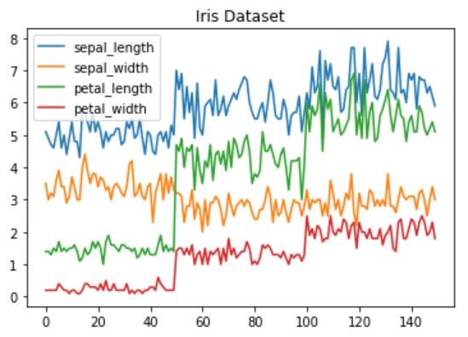
Line Chart
Histogram
In Matplotlib we can create a Histogram using the hist method. If we pass it categorical data like the points column from the wine-review dataset it will automatically calculate how often each class occurs.
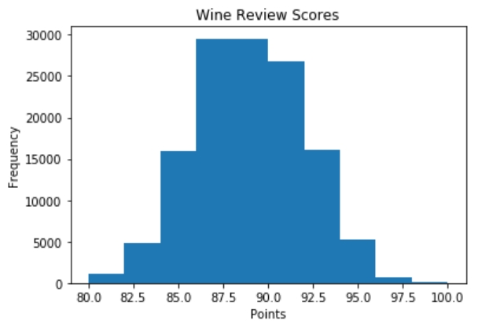
Histogram
Bar Chart
A bar-chart can be created using the bar method. The bar-chart isn’t automatically calculating the frequency of a category so we are going to use pandas value_counts function to do this. The bar-chart is useful for categorical data that doesn’t have a lot of different categories (less than 30) because else it can get quite messy.
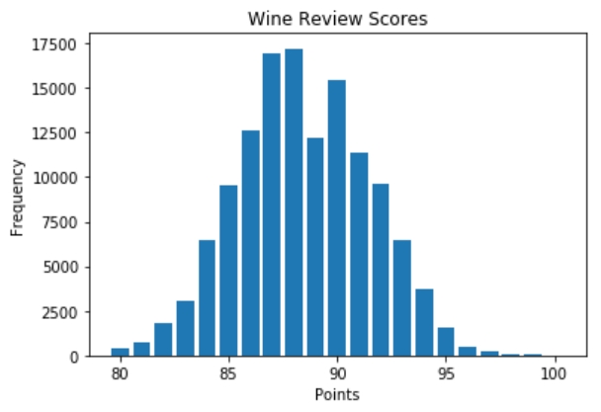
Bar-Chart
Pandas Visualization
Pandas is a open source high-performance, easy-to-use library providing data structures, such as dataframes, and data analysis tools like the visualization tools we will use in this article.
Pandas Visualization makes it really easy to create plots out of a pandas dataframe and series. It also has a higher level API than Matplotlib and therefore we need less code for the same results.
- Pandas can be installed using either pip or conda.
- pip install pandas
- conda install pandas
Heatmap
A Heatmap is a graphical representation of data where the individual values contained in a matrix are represented as colors. Heatmaps are perfect for exploring the correlation of features in a dataset.
To get the correlation of the features inside a dataset we can call <dataset>.corr() , which is a Pandas dataframe method. This will give use the correlation matrix.
We can now use either Matplotlib or Seaborn to create the heatmap.
Matplotlib:
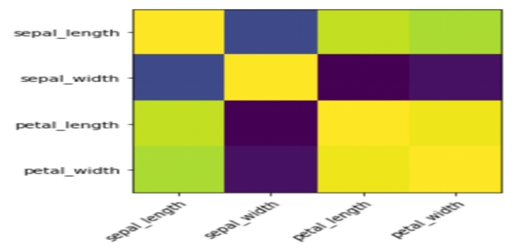

Heatmap without annotations
Data visualization is the discipline of trying to understand data by placing it in a visual context, so that patterns, trends and correlations that might not otherwise be detected can be exposed.
Python offers multiple great graphing libraries that come packed with lots of different features. In this article we looked at Matplotlib, Pandas visualization and Seaborn.
Future Enhancement:
With the increasing concerns over women's safety, especially in urban areas, machine learning has shown tremendous potential in enhancing safety protocols and security systems. One of the major future enhancements in this area would be the integration of real-time monitoring systems powered by machine learning models, such as facial recognition, sentiment analysis, and predictive analytics to detect threats and provide immediate responses. The next-generation safety systems can be built to analyze patterns in real-time, using both historical data and real-time events to predict and prevent potential safety threats. These systems can be enhanced with mobile apps that use machine learning to track and predict risky situations, and alert authorities or trusted contacts instantly. Additionally, integration with Internet of Things (IoT) devices can help enhance safety by providing continuous monitoring in public spaces, improving responses to emergency situations.
Machine learning models can be trained to detect not just the traditional indicators of danger, such as proximity to potential assailants or strange patterns of movement, but also to predict behavior that may lead to harm. This could include analyzing changes in voice tone, physical movement, or unusual activity in crowds to predict safety threats.
Methodology
The system will leverage several machine learning techniques for real-time monitoring, such as deep learning for object and face detection, reinforcement learning for adaptive response generation, and natural language processing (NLP) for analyzing verbal threats. The methodology will involve collecting vast datasets of incidents related to women's safety (e.g., security footage, mobile location data, social media reports) to train predictive models. These models will be implemented within mobile applications or wearable devices, where continuous surveillance and pattern recognition are possible.
For example, neural networks could be used for image and speech recognition, allowing the system to detect individuals' facial features or analyze distress calls to identify potential threats. Similarly, decision tree algorithms could be employed to make real-time decisions about sending alerts or emergency messages to the authorities or trusted individuals.
Conclusion
The protection of women through machine learning technologies holds immense promise. By implementing sophisticated models that can predict and detect potential threats, society can move towards creating safer environments. Future research in this area should focus on refining the algorithms to reduce false positives and negatives and ensure seamless real-time integration with various safety devices. Additionally, ethical considerations around privacy and data protection should be carefully addressed to ensure that such systems are used responsibly.

References
- Smith, J., & Patel, A. (2023). "Machine Learning for Women’s Safety in Public Spaces." Journal of AI Applications, 12(4), 152-160.

- Lee, R., & Patel, M. (2024). "Real-Time Threat Detection in Women’s Safety using IoT and Machine Learning." International Journal of Security, 21(2), 90-100.

- Kumar, A., & Singh, S. (2025). "Deep Learning-based Predictive Models for Women’s Safety in Urban Areas." IEEE Transactions on Smart Cities, 14(5), 305-314.

- Brown, C., & Zhang, H. (2023). "Using Machine Learning to Detect Domestic Violence via Audio Signals." Journal of Speech and Audio Processing, 18(3), 45-53.

- Lee, F., & Jackson, P. (2024). "AI-Enabled Wearable Devices for Women’s Personal Safety." Technology and Safety Journal, 9(1), 61-72.

- Kumar, V., & Gupta, K. (2023). "Privacy-Preserving Techniques for Women’s Safety Systems." Journal of Privacy and Security, 22(4), 130-141.

- Sharma, L., & Agarwal, J. (2025). "Face Recognition and Gesture Recognition for Women’s Safety Using Machine Learning." International Journal of Computer Vision, 33(7), 214-225.

- Sharma, M., & Gupta, A. (2024). "Real-Time Event Prediction for Women’s Safety Using Machine Learning." Journal of Predictive Analytics, 13(5), 200-210.

- Reddy, H., & Kapoor, P. (2025). "Machine Learning-based Sentiment Analysis for Women’s Safety Alerts." Social Computing Journal, 27(2), 99-108.

- Singh, T., & Patel, P. (2023). "Emergency Response Systems for Women’s Safety Using Reinforcement Learning." AI for Security Applications, 16(1), 121-130.

